**Week 06**

**W06 Learning Activities**

1. [Web Developer Roadmap](https://byui-cse.github.io/wdd130-ww-course/week06/prepare-web-developer-roadmap.html)
2. [Web Designer Roadmap](https://byui-cse.github.io/wdd130-ww-course/week06/prepare-web-designer-roadmap.html)
3. [Current Careers in Web Design and Development](https://byui-cse.github.io/wdd130-ww-course/week06/prepare-wdd-careers.html)

**Assignment**

Complete the rafting website project by adding two more pages to your wwr site.

1. W06 Assignment: Rafting Site - [Home and Trips Pages](https://byui-cse.github.io/wdd130-ww-course/week06/prove-rafting.html)

**WDD Careers: Web Developer Roadmap**

**Overview**

A roadmap is a guide to get from one location to another. A Web Developer Roadmap provides information and guidance on what to learn in order to be successful in the field of web development.

**Activity Instructions**

1. Go to [Developer Roadmaps](https://roadmap.sh/frontend?r=frontend-beginner) website and review the **titles** of the role based, skills based, and best practice roadmaps.  
   **Do you recognize some of the technologies and terms being used in those titles?**
2. Click on the **Frontend** Roadmap.
3. Review the roadmap and identify technologies and concepts that you have studied.
4. Briefly scan the **Internet** linked modules such as "What is HTTP?" and "What is a Domain Name?". Is there something in any of those modules that you wanted to know more about?
5. Scan the **HTML** and **CSS** linked modules for topics that you recognize from the course. What else interests you here?

In this week's activities you will search current job openings in the field of web design and development which will list technologies and skills that are required and preferred.

[**Back**](https://byui-cse.github.io/wdd130-ww-course/week06/index.html)

**WDD Careers: Web Designer Roadmap**

**Overview**

This activity is meant to be an overview of the field in Web Design and User Experience (UX) occupations.

**Activity Instructions**

1. Navigate to [Web Designer Roadmap - A Beginners Guide](https://www.codelivly.com/web-designers-roadmap-a-beginners-guide/).
2. Review all the titled sub-sections under the *1. Develop the necessary skills* section.
3. Is there anything in this skills list that interests you more than others?
4. Navigate to [Web Designer Interview Questions and Answers](https://www.ramotion.com/blog/web-design-interview-questions/).
5. Scroll down to the callout section labeled **Web Designer Interview Questions**.  
   Review the questions and sample answers/discussion points. Is there anything you can add?  
   What questions do you feel that you can answer?

In this week's activities you will search current job openings in the field of web design and development which will list technologies and skills that are required and preferred.

[**Back**](https://byui-cse.github.io/wdd130-ww-course/week06/index.html)

**Web Design and Development Careers**

**Overview**

In this activity, you will research current job descriptions in the field of web design and development, preferably in your region, using appropriate search terms. The goal is to provide context to the value of continuing your development and learning in areas of interest and market demand.

**Activity Instructions**

1. Navigate to [LinkedIn Job Search](https://www.linkedin.com/jobs/search) or an equivalent job search site.
2. Find a full-time job description in your area or that allows remote workers that has one of the following acceptable **titles** or portion of the title in it. Filter your search to only return jobs for **internship, entry-level, or junior level** positions if possible.
   * Web Developer
   * Web Designer
   * Front-end Developer
   * Front-end Designer
   * Front-end Engineer
   * Front-end Architect
   * SEO Analyst
   * SEO Specialist
   * SEO Manager
   * SEO Director
3. Using the course's Microsoft Teams **general** channel, post a summary of the job listing by providing the following information:
   * Job Title
   * Company Name
   * Location
   * Job Description
   * Required Competencies
4. Comment on your peers post pointing out job descriptions that are of interest to you and what is common between the list requirements per job title/role.

**W06 Rafting Site Project - Complete**

**Overview**

Complete the rafting site project by adding two more pages to the site, the Home and Trips pages.

"Life is a journey, not a destination. As we travel along life's pathway, we encounter challenges, obstacles, and uncertainties. But we must not permit these to divert us from our destiny. We must continue on, even when the road ahead seems uncertain. We must finish strong."

*- President Thomas S. Monson, "Finishers Wanted", Ensign, June 2001*

**Instructions**

1. Improve your rafting project's **About Us** and **Contact Us** pages as needed given prior feedback.
2. Review the [Rafting Site Project Description](https://byui-cse.github.io/wdd130-ww-course/week03/rafting-site-description.html) including the provided home page wireframe.
3. Design and develop the two remaining pages for the rafting project.
   1. [Home](https://byui-cse.github.io/wdd130-ww-course/week06/prove-rafting-home.html) page requirements
   2. [Trips](https://byui-cse.github.io/wdd130-ww-course/week06/prove-rafting-trips.html) page requirements
4. Make sure all four pages having common navigation and that all the links work.

Consider using the **Validate Link**s tool found in the Web Developer extension.

1. Review the [Web Development Standards Checklist](https://byui-cse.github.io/wdd130-ww-course/dev-standards.html) and compare each of your pages against the standards.
2. In a private browser window, load your site and use Dev Tools **Lighthouse** to run a report for **Desktop** in the performance, accessibility, best practices, and SEO categories. Review the notes provided.

**NOTE:** The Lighthouse report will not be assessed by the graders. It is provided as a tool to help you identify areas of improvement. Do not worry about fixing all the issues, just those you recognize.

**Testing and Assessment**

1. All folders and files on the rafting project website must meet the course's [naming conventions](https://byui-cse.github.io/wdd130-ww-course/week01/prepare-naming-conventions.html).
2. The validation report at <https://validator.w3.org/nu> reports no errors for every page.
3. The validation report at <https://jigsaw.w3.org/css-validator/> reports no errors and  
   only **one (1) css file** was used for the entire project.
4. Each page **title** element has relevant content that is reflective of the page content and the website as a whole on all pages.
5. Each page **meta description** element has relevant content that is reflective of the page content.
6. No **color contrast** violations at the AA level. Use DevTools CSS Overview in DevTools to run the test on each page.
7. The **Home** page contains a hero image with heading, a newsletter, call to action, uses CSS Grid as assigned, and contains the required content.
8. The **Trips** page contains contains the required content.

Full credit consideration requires layouts on these two pages that is beyond a simple, single column layout, is visually appealing, and adheres to design principles of ease of use, uniform alignment, proximity of components, and use of white space.

1. Each individual page does not exceed the **500 kB transferred** size as reported by DevTools Network with an empty cache reload. The focus here is that images have been optimized and that no outside library/framework is used.

Note that The Google Map in the Contact Us page does **not** count when measuring total transferred kilobytes per page.

**Submission**

1. Commit your changes and push them to your wdd130 GitHub Pages enabled repository.
2. Submit the your rafting project URL in I-Learn.

https://githubusername.github.io/wdd130/wwr/

## The Whitewater Rafting Site Project Description

### Overview

The Whitewater Rafting Site Project is a website project that you will work on throughout the course. The goal of the project is to meet the course outcomes and objectives through development specifications that match learning activities and assignments. You will be involved in the planning, design, development, and deployment of your own whitewater rafting site. Some of the pages have more prescriptive requirements that others, and there will be opportunities for you to demonstrate competency and your own creativity.

### Description

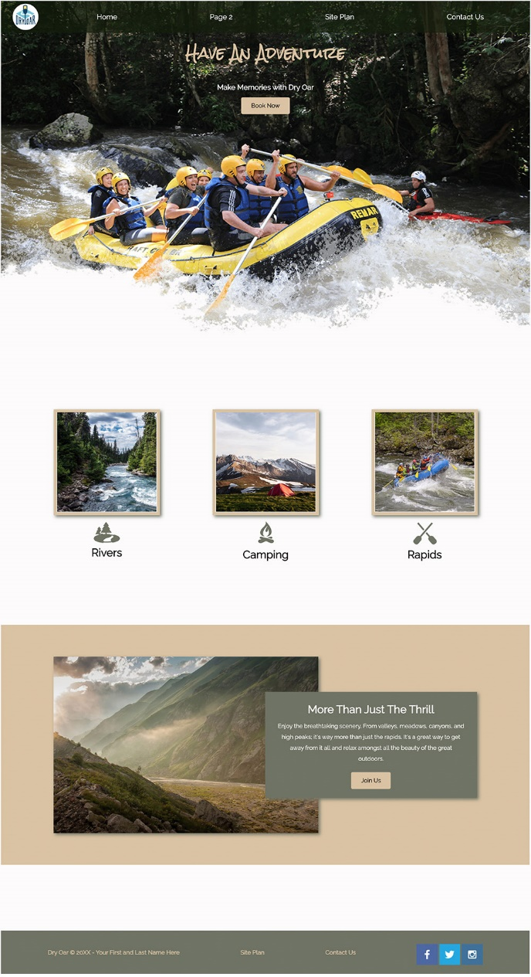Whitewater rafting is a type of recreation that involves navigating a non-motorized watercraft down free flowing rivers. A rafting company organizes trips, provides the watercraft, life jackets, etc., and typically offers experienced guides to take passengers down a river. The business intent is to provide a thrilling and safe experience to individuals and groups for a fee.

#### Examples of Whitewater Rafting Organizations

* [All-Outdoors California Whitewater Rafting](https://www.aorafting.com/)
* [Peru Rafting](https://perurafting.com/)
* [Salmon River Experience](https://salmonriverexperience.com/trips)
* [Nile River Explorers](https://www.raftafrica.com/uganda-jinja-nile-white-water-river-rafting/)

### Project Specifications

#### General Design

* The content is custom built with valid, semantic, and contemporary HTML and CSS.
* The design is consistent throughout the site providing ease of navigation, and supporting positive user experiences.

#### Page Specifications

* **📄 Home** - The home page will contain some attention grabbing information including company information, call(s) to action, appealing graphics, and other items.
* **📄 About Us** - This page provides an overview, information about its owners and staff, and basic trip summaries.
* **📄 Trips** - This page provides detailed information and examples of the different adventures or trips that the company offerings including available equipment.
* **📄 Contact Us** - Provides contact information and a form to obtain user input including questions and comments.

#### Developmental Specifications

These specifications are driven by the learning outcomes of the course and by specific web design and development concept objectives that are presented in the lessons. Each week as new concepts are introduced, new content requirements will be added to the project. Here are the general, objective-based specifications:

* The course's development standards are met.
* The site is structured with valid, standards-based, semantic markup that is responsive and does not include styling.
* The site is styled and presented with valid, standards-based CSS.
* The site meets this listed functional, content, and behavior specifications.
* The design ensures that the site meets user expectations by providing a positive experience through adhering to standard design principles and utilizing easy-to-use interfaces.
* The published site meets the intent of mastery the course learning outcomes.

## W06 Rafting Project: Trips/Adventures Page

### Overview

The rafting site project contains a total of four (4) pages. The **Trips** page provides information about the specific trips, adventures, and packages that the rafting company offers to clients.

Reference examples of the type of content that could be included on the **trips** page:  
[Rafting Site Description](https://byui-cse.github.io/wdd130-ww-course/week03/rafting-site-description.html)

### Instructions

#### Setup and Design

1. Create an **trips.html** in the **wwr** directory that contains the same header, navigation, and footer as the other pages on the site. (Hint: copy and paste like you did for the Contact Us page.)
2. Prep the new page by changing the **title** and **meta** description in the **head** section. Remove the non-relevant content within the **main** element.
3. The following components are required on the **Trips** page:
   1. Call to action to contact the company. This action opens the **Contact Us** page on the site.
   2. At least three detailed trip descriptions with photos.
   3. A table outlining all the available trips with relevant information.
   4. For full credit consideration, you cannot just have a simple, single column flow layout.
4. Create a **wireframe** design sketch of the **Trips** page layout and content. Be sure that you include the required components, described above, in your layout. Save the wireframe as an image in your wwr **images** folder.
5. Be creative in your design, but remember that your header, navigation, and footer layout and content should be the same as other pages on the rafting site.
   1. [Layout and Composition](https://youtu.be/a5KYlHNKQB8)
   2. [Common Web Layouts](https://developer.mozilla.org/en-US/docs/Learn/Common_questions/Design_and_accessibility/Common_web_layouts)
   3. Look at other websites for inspiration

#### Build

1. Build the structure of your **trips.html** page using HTML.
2. Using the same **rafting.css** file, make additions and any required changes to the CSS.
3. Create a **link to the Trips page wireframe image** in the footer of your **trips.html** page only.

#### Testing

1. **Validate** your HTML and CSS using the **Web Developer** browser extension.
2. **Validate** accessibility using the **Web Developer** browser extension.
3. Check for [color contrast](https://developer.mozilla.org/en-US/docs/Learn/Tools_and_testing/Cross_browser_testing/Accessibility#color_and_color_contrast) violations at the AA level. Use DevTools **CSS Overview** to test: [How to Use CSS Overview](https://video.byui.edu/media/t/1_amt1b8xy)
4. Every page in this course will be expected to pass the [development standards checklist](https://byui-cse.github.io/wdd130-ww-course/dev-standards.html). Review your rendered page and markup against this checked items.

**W06 Rafting Project: Home Page**

**Overview**

Add the **Home** page to the rafting site project.

Be sure to practice good development techniques including planning before beginning the page build.

**Home Page Requirements**

1. The home page is named **index.html** and is located in the **wwr** rafting website project directory.

The name **index** is a default name which is referenced by the web server to be delivered to the requesting client for any directory in which it resides.

1. The common CSS file is used throughout the site, **rafting.css**.
2. One large **full-width** 'hero' image is used and it includes a heading message.
3. A newsletter sign up **form** that requests at least a name and an email.
4. A call to action with link to the trips.html page that compels visitors to visit the trips page.
5. A **CSS grid** layout with at least two additional images and corresponding content about the white water rafting site purpose and offerings.
6. For full credit consideration, the layout cannot be a simple, single column flow layout.
7. Be creative in your design, but remember that your header, navigation, and footer layout and content should be the same as other pages on the rafting site. Why?

## W06 Rafting Project: Trips/Adventures Page

### Overview

The rafting site project contains a total of four (4) pages. The **Trips** page provides information about the specific trips, adventures, and packages that the rafting company offers to clients.

Reference examples of the type of content that could be included on the **trips** page:  
[Rafting Site Description](https://byui-cse.github.io/wdd130-ww-course/week03/rafting-site-description.html)

### Instructions

#### Setup and Design

1. Create an **trips.html** in the **wwr** directory that contains the same header, navigation, and footer as the other pages on the site. (Hint: copy and paste like you did for the Contact Us page.)
2. Prep the new page by changing the **title** and **meta** description in the **head** section. Remove the non-relevant content within the **main** element.
3. The following components are required on the **Trips** page:
   1. Call to action to contact the company. This action opens the **Contact Us** page on the site.
   2. At least three detailed trip descriptions with photos.
   3. A table outlining all the available trips with relevant information.
   4. For full credit consideration, you cannot just have a simple, single column flow layout.
4. Create a **wireframe** design sketch of the **Trips** page layout and content. Be sure that you include the required components, described above, in your layout. Save the wireframe as an image in your wwr **images** folder.
5. Be creative in your design, but remember that your header, navigation, and footer layout and content should be the same as other pages on the rafting site.
   1. [Layout and Composition](https://youtu.be/a5KYlHNKQB8)
   2. [Common Web Layouts](https://developer.mozilla.org/en-US/docs/Learn/Common_questions/Design_and_accessibility/Common_web_layouts)
   3. Look at other websites for inspiration

#### Build

1. Build the structure of your **trips.html** page using HTML.
2. Using the same **rafting.css** file, make additions and any required changes to the CSS.
3. Create a **link to the Trips page wireframe image** in the footer of your **trips.html** page only.

#### Testing

1. **Validate** your HTML and CSS using the **Web Developer** browser extension.
2. **Validate** accessibility using the **Web Developer** browser extension.
3. Check for [color contrast](https://developer.mozilla.org/en-US/docs/Learn/Tools_and_testing/Cross_browser_testing/Accessibility#color_and_color_contrast) violations at the AA level. Use DevTools **CSS Overview** to test: [How to Use CSS Overview](https://video.byui.edu/media/t/1_amt1b8xy)
4. Every page in this course will be expected to pass the [development standards checklist](https://byui-cse.github.io/wdd130-ww-course/dev-standards.html). Review your rendered page and markup against this checked items.